**ECEN 452 Pre-Lab 2**

1.

a. Miscrostrip line calculation:

(1.) 50 Ohm

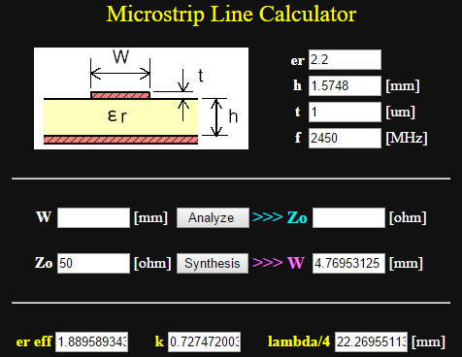Characteristic impedance=50 ohm

Width= 4.769 mm

(2.) 100 Ohm

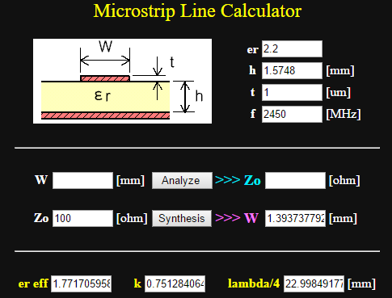Length= 22.998 mm

Characteristic impedance=100 ohm

Width= 1.393 mm

(3.)200 Ohm

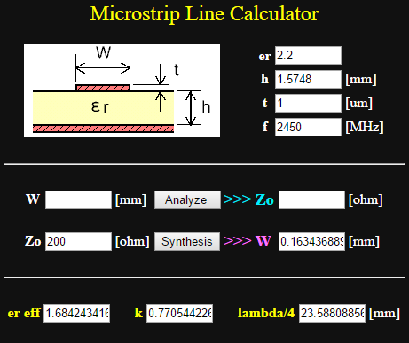Characteristic impedance=200 ohm

Width= 0.1634 mm

b. Z0lver simulation:

(1.) Simulation model

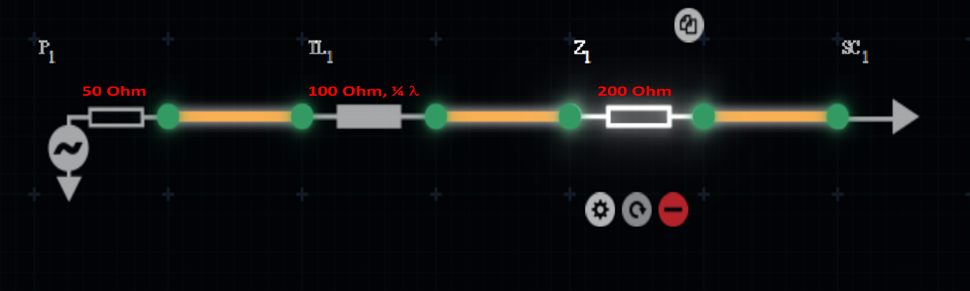

(2.) Simulated S-parameter spectra

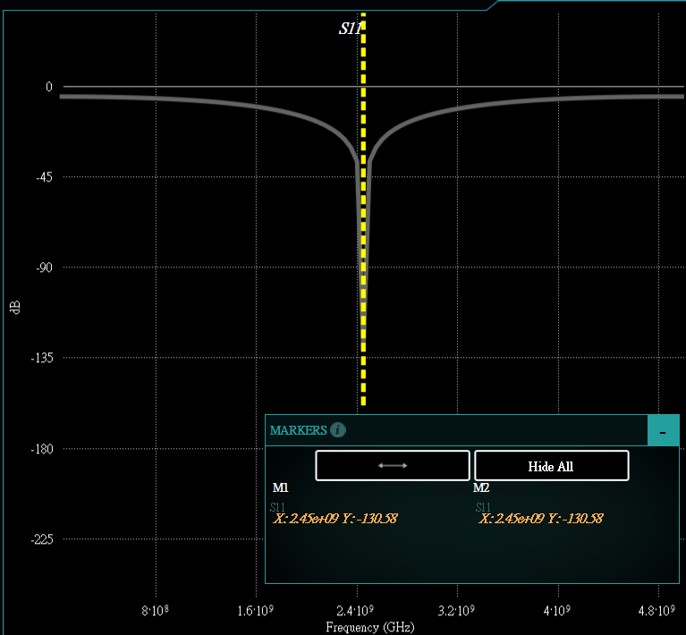The reflection coefficient for the structure has a deep point at 2.45 GHz.

2.

a. Smith chart design

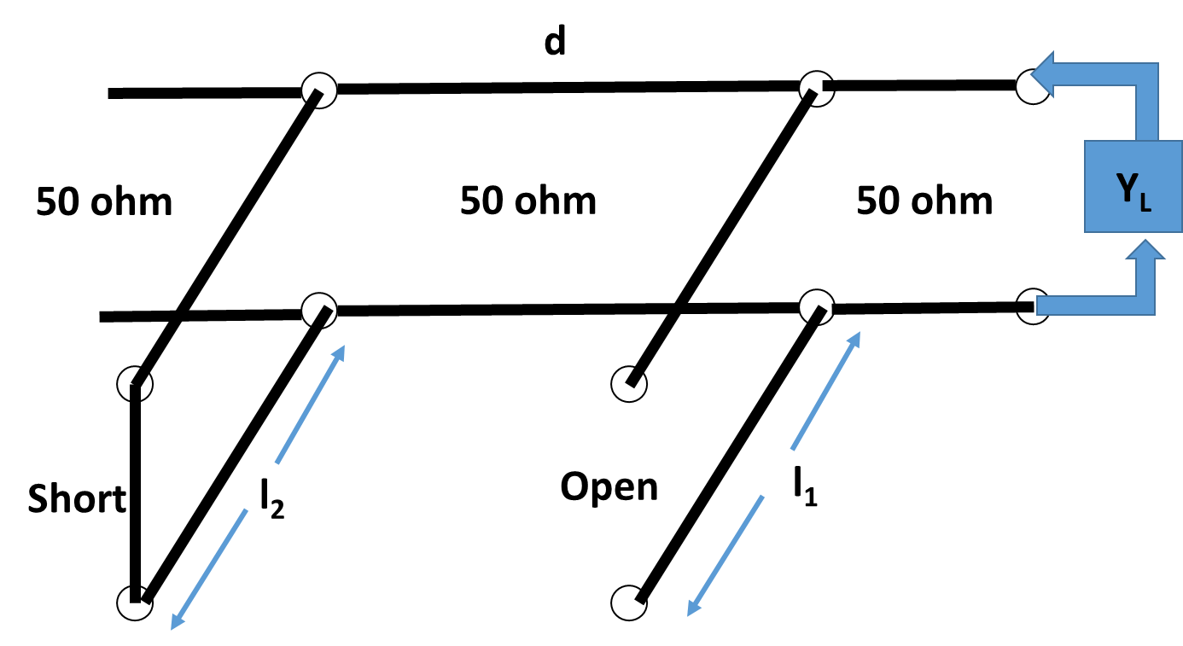 The double stub tuner circuit for this question is shown in the right side.

The first stub is open circuit. The second stub is short circuit. The distance between two stubs is /8.

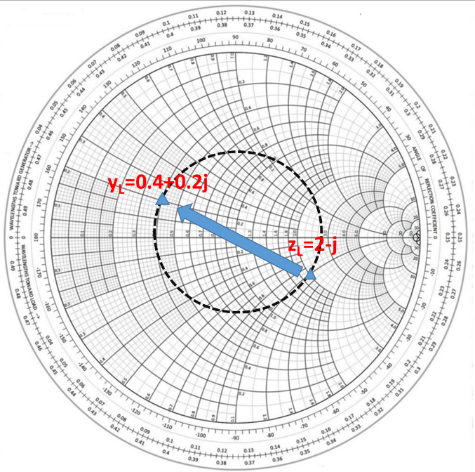

The normalized load admittance is yL=0.4+0.2j.

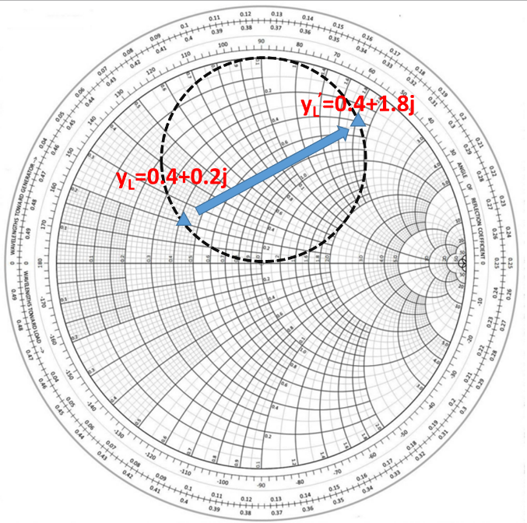Rotated 1+jB conductance circle by distance d (/8). Then, get the susceptance of the first stub value is 1.6.

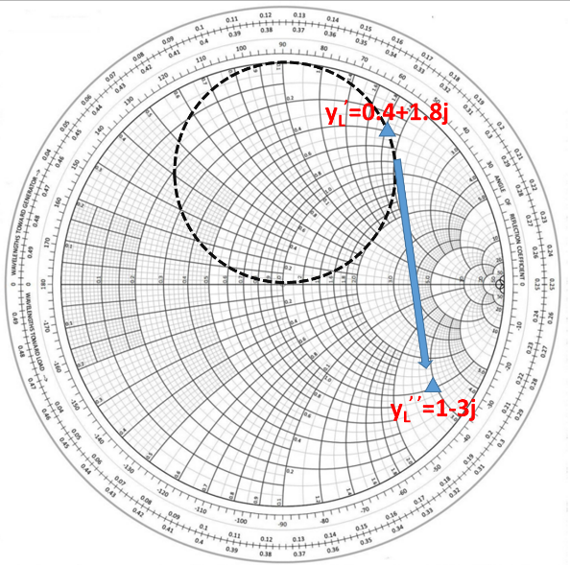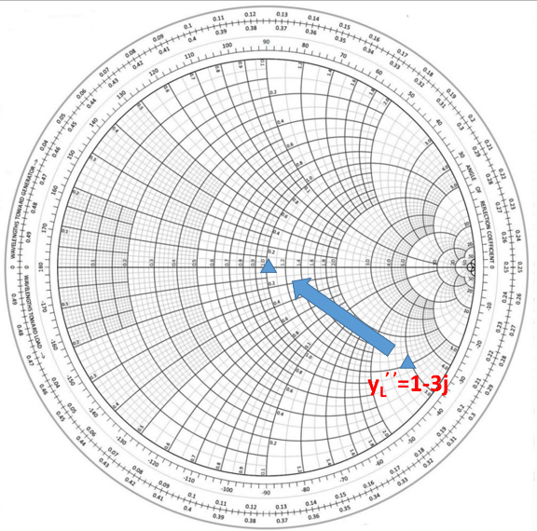

Rotating yL’ by /8 toward generator, get the yL’ ’=1+3j. The susceptance of the second stub should be 3j.

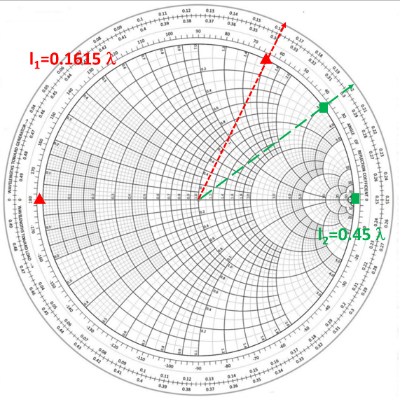

The length of the open circuit stub and short circuit stub are found as

l1=0.1615  l2=0.45 

b. Z0lver simulation:

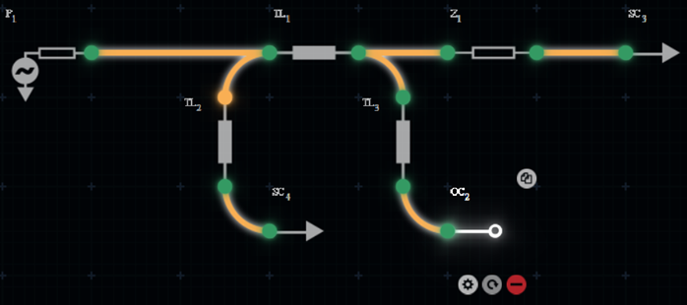(1.) Simulation model

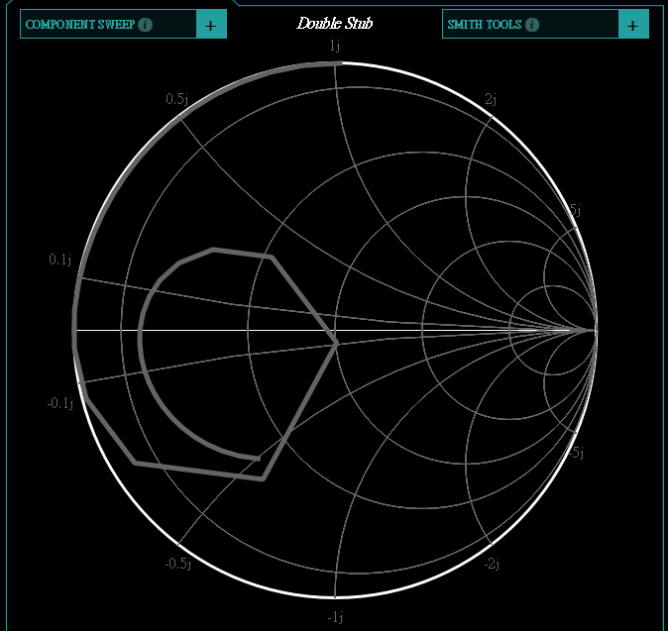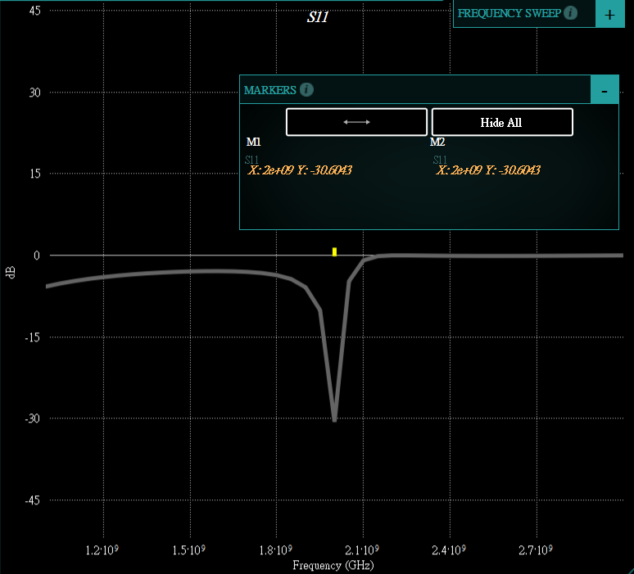(2.) Simulated S-parameter spectra and Smith chart

The reflection coefficient and smith chart for this double stub design has good match at 2.0 GHz.